MABBS HALL RESIDENT ‘S BIRTHDAY
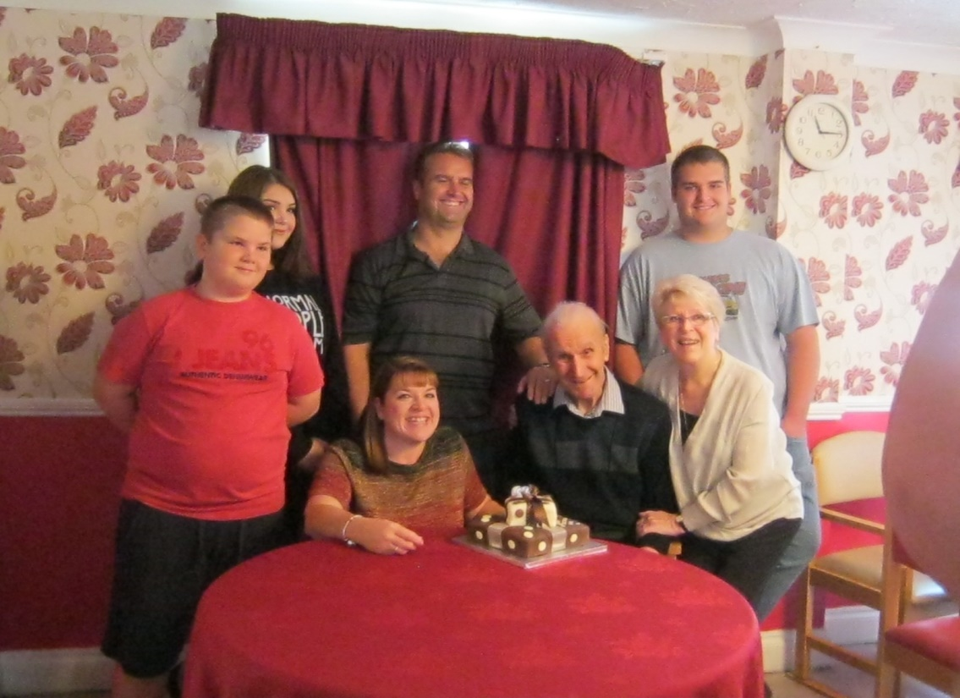
Mr Kenneth Bent celebrated his 80th Birthday with all his family on 27/10/2016

